Trans-KARST 2004

International Transdisciplinary Conference

on

Development and Conservation of Karst Regions

Ha Noi, Vietnam

13 - 18 September 2004

Second Announcement

Under the auspices of UNESCO
(IGCP Project 448 and IHP)

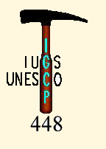

Under the patronage of the UIS
(Union Internationale de Spéléologie)



With the support of:
Flemish Interuniversity Council (VLIR), Belgium
Catholic University Leuven (KUL), Belgium
Free University Brussels (VUB), Belgium
Royal Belgian Institute of Natural Sciences Geological Survey of Belgium (GSB), Belgium
Fauna & Flora International (FFI), Vietnam
International Union for Conservation of Nature (IUCN)
International Association of Hydrogeologists (IAH)

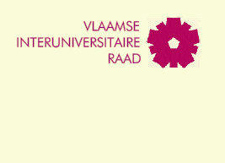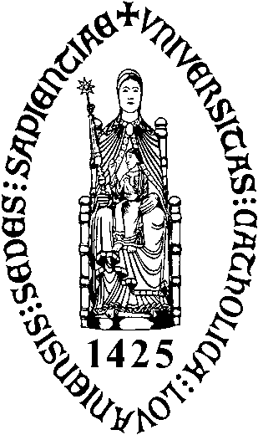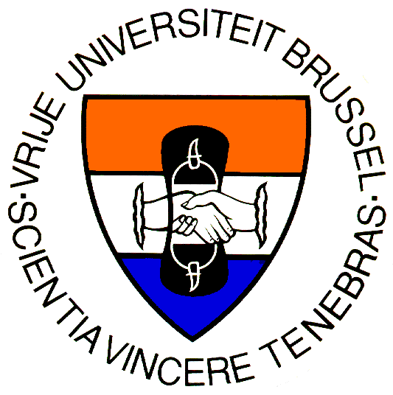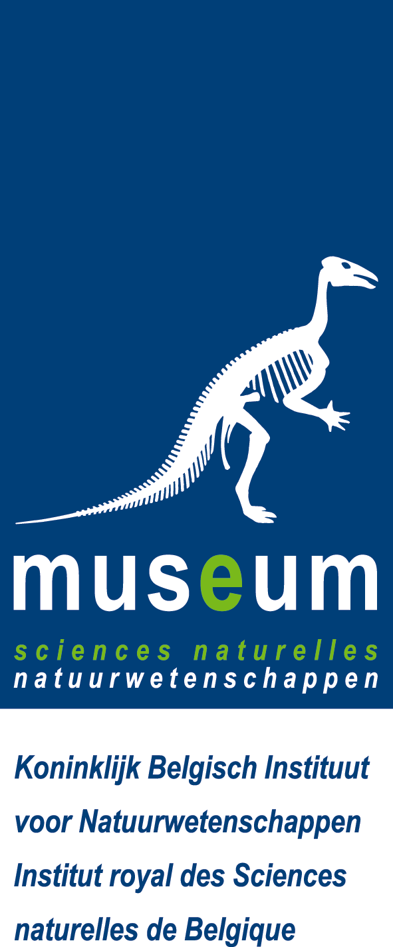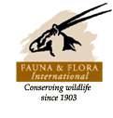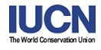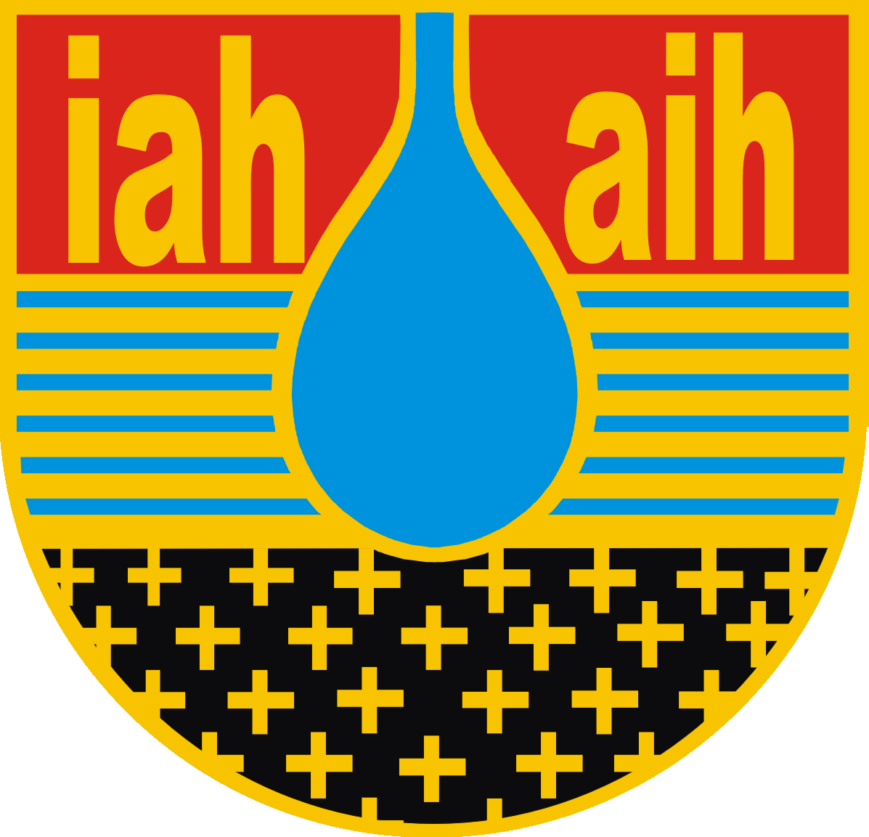

Trans-KARST 2004

International Transdisciplinary Conference

on
Development and Conservation of Karst Regions

Ha Noi, Vietnam

13 - 18 September 2004

Rationale:
The policies and practice of sustainable development often meet considerable difficulty in implementation due to the many interests at stake. Political, social, cultural, environmental and economic considerations must all be met. This is particularly the case in karst areas where communities are often poor. Despite their magnificent scenery and cultural and natural diversity, their development is defined primarily in economic terms, generally to the detriment of the karst environment.

The findings of two transdisciplinary research projects in karst areas in Vietnam confirm that sustainable development is not simply a question of controlling natural conditions and designing technical interventions. The cultural context, social organization and learning processes of the socio-cultural systems and communities must be understood and taken into account. The tensions between socio-economic development and conservation require integrated natural and social science approaches.
Deadlines:
- 2nd circular October 2003
- Submission of abstracts for papers and posters January 15, 2004
- Notification of acceptance March 1, 2004
- Submission of extended abstracts April 30, 2004
- Booking of excursions and submission of reviewed extended abstracts June 30, 2004
- Notification of full papers July 2004
- Submission of full papers October 2004
Sponsors:
- Vietnam’s Ministry of Natural Resources and Environment (MNRE)
- Belgian Embassy in Vietnam
- Flemish Interuniversity Council (VLIR), Belgium
- Royal Belgian Institute of Natural Sciences Geological Survey of Belgium (GSB), Belgium
- UNESCO (IGCP Project 448 and IHP)
- Union Internationale de Spéléologie
- International Union for Conservation of Nature (IUCN)
- International Association of Hydrogeologists
- Fauna & Flora International (FFI), Vietnam
Organizers:
- Research Institute of Geology and Mineral Resources (RIGMR, Ministry of Natural Resources and Environment), Vietnam
- Institute of Ethnology (IE, National Center for Social Sciences and Humanities), Vietnam
- Forest Protection Department (FPD, Ministry of Agriculture and Rural Development), Vietnam
Organizing committee:
- Dr. Nguyen Xuan Khien, RIGMR  - Dr. Nguyen Linh Ngoc, RIGMR  - Dr. Do Tuyet, RIGMR  - Dr. Tran Tan Van, RIGMR  - Dr. Pham Quang Hoan, IE  - Dr. Nguyen Van Minh, IE  - Dr. Dinh Van Thanh, MNRE | - Ms. Tran Thi Minh Ha, MNRE  - Prof. Dr. Jan Masschelein, KUL  - Dr. Fadi Nader, UIS  - Dr. Michiel Dusar, GSB  - Dr. Okke Batelaan, VUB  - Dr. Mark Infield, FFI  - Dr. Olivier Tessier, FEO
International scientific committee:
- Prof. Dr. Alain Dassargues, Liège Univ. and KUL, Belgium
- Prof. Dr. Alexander Klimtchouk, UIS Vice-President, Ukraine
- Prof. Dr. Camille Ek, Liège Univ., Belgium
- Prof. Dr. Cees Leeuwis, Wageningen Univ., the Netherlands
- Prof. Dr. Chris Groves, Western Kentucky Univ., USA
- Prof. Dr. Danny Wildemeersch, KUL, Belgium
- Prof. Dr. Duong Duc Kiem, RIGMR
- Prof. Dr. Elery Hamilton-Smith, Chair IUCN/WCPA Task Force on Cave/Karst Protection, Australia
- Prof. Dr. François Zwahlen, Neuchâtel Univ, Switzerland
- Prof. Dr. Hilaire De Smedt, VUB, Belgium
- Prof. Dr. Khong Dien, IE
- Prof. Dr. Nguyen Quang My, Vietnam’s Karst/Cave Association, Ha Noi National Univ.
- Prof. Dr. Pavel Bosak, UIS President, Prague Academy of Sciences, Czech Republic
- Prof. Dr. Phan Cu Tien, RIGMR
- Prof. Dr. Rudy Swennen, KUL
- Prof. Dr. Song, Linhua, Beijing Academy of Sciences, China
Conference Secretariat:
- Dr. Tran Tan Van, RIGMR  - Dr. Pham Kha Tuy, RIGMR  - Dr. Vu Thanh Tam, RIGMR  - Dr. Dang Huy Ram, MNRE  - Mr. Thai Duy Ke, RIGMR | - Mr. Vo Xuan Dinh, RIGMR  - Ms. Nguyen Kim Quy, RIGMR  - Mr. Nguyen Dai Trung, RIGMR  - Mr. Dinh Xuan Quyet, RIGMR  - Mr. Do Van Thang, RIGMR
Correspondence Address:
Dr. Tran Tan Van
Research Institute of Geology and Mineral Resources (RIGMR)
Thanh Xuan, Ha Noi, Vietnam
Tel: 84-4-854-3107 / Fax: 84-4-854-2125
Email: trantv@hn.vnn.vn
http://www.vub.ac.be/trans-karst2004
Conference Venue:
Conference Hall
Army Hotel
33C Pham Ngu Lao St.
Ha Noi, Vietnam

Trans-KARST 2004 - International Transdisciplinary Conference on Development and Conservation of Karst Regions

Invitation
The Organizing Committee of the International Transdisciplinary Conference on Development and Conservation of Karst Regions (Trans-KARST 2004) has the pleasure of inviting you to participate in this conference, which will take place in Ha Noi, Vietnam from September 13 - 18, 2004.
Trans-KARST 2004 will:
- Offer a forum to discuss basic and applied research findings and methodologies which can contribute to the management and development of karst areas;
- Help strengthen interest in the preservation of geodiversity, biodiversity and cultural diversity through promotion of sustainable relationships between them;
- Stimulate communication between researchers, practitioners and policy makers working in karst landscapes;
- Explore ways to integrate natural and social sciences approaches in the management of karst systems.
The Conference will be organized around 4 major themes; each refers to a set of issues of particular relevance to or concern for the development and conservation of karst regions.
The first theme - Policy and management of land and water resources - includes such topics as balancing public and private responsibilities; reconciling economic development and nature conservation in land-use planning; the technical and social requirements for water supply, soil conservation and flood protection etc.
The second theme - Development of infrastructure and assessment of environmental risks and hazards - includes such topics as karst dissolution and collapse; the effects of climate change; flooding, flood controls and dam construction; environmental mitigation of infrastructure development; managing pollution of water resources in karst systems; monitoring karst water resources; karst structure, groundwater modeling and hydrological cycles; water tracing and vulnerability mapping; cave exploration and structural geology etc.
The third theme - Conservation of eco-systems - includes such topics as managing tourism in sensitive areas; developing and protecting show caves; cave exploration; conserving karst specific biodiversity; bio-diversity quantification and monitoring; sustainable forest management; impacts of land-use changes on cultural heritage and landscape; environmental impact and mitigation assessment etc.
And the last theme - Integration of natural and social science approaches - includes such topics as transdisciplinary research collaborations; multi-stakeholder collaboration in policy and practice; education and social learning; participatory research methodologies; social and geoscientific applications of GIS and remote sensing.
We look forward to welcoming you to Ha Noi, Vietnam and to the Trans-KARST 2004.
Yours Sincerely,
Dr. Nguyen Xuan Khien
President of Trans-KARST 2004

Trans-KARST 2004 - International Transdisciplinary Conference on Development and Conservation of Karst Regions

Agenda
(13 - 18 September 2004)

The Trans-KARST 2004 program will consist of plenary lectures, session presentations, business meetings and posters, which will focus on integrated topics of development and conservation in karst regions.

September 11, 2004, Saturday
 | Business Meeting (1): UIS annual meeting. Chair: Prof. Dr. P. Bosak, UIS President
September 12, 2004, Sunday
 | Business Meeting (1) (Continuing): UIS annual meeting.
16:00-18:00 | Registration, Conference Hall, Army Hotel, 33C Pham Ngu Lao St.
18:00-19:00 | Icebreaker party
September 13, 2004, Monday
7:00-8:30 | Registration
8:30-9:30 | Opening Ceremony  An Introduction of VIP by Ms. Tran Thi Minh Ha  Welcoming Address by Vietnam’s Minister of Natural Resources and Environment  Opening Address by Dr. Nguyen Xuan Khien, RIGMR and Prof. Dr. J. Masschelein, KUL
9:30-10:30 | Plenary Reports. Chair: Prof. Dr. F. Zwahlen, Neuchâtel University  Plenary report No.1: Searching for principles to guide sustainable management of karst: lessons from science, Prof. Dr. P. Williams, Auckland University
10:30-11:00 | Coffee break
11:00-12:00 | Chair: Prof. Dr. D. Wildemeersch, KUL  Plenary report No.2: Transdisciplinary research collaboration, Prof. Dr. C. Leeuwis, Wageningen Univ.
12:00-13:30 | Lunch-time and posters
13:30-14:30 | Chair: Prof. Dr. M. Dusar, GSB  Plenary report No.3: Conservation of karst eco-systems, Prof. Dr. C. Groves, Western Kentucky Univ.
14:30-15:30 | Concurrent Sessions (Paper presentations of 20 minutes each)  - Session I: Policy and management of land and water resources. Chair: Dr. Dinh Van Thanh  - Session II: Development of infrastructure and assessment of environmental risks and hazards. Chair: Prof. Dr. A. Klimtchouk  - Session III: Conservation of eco-systems. Chair: Prof. Dr. E. Hamilton- Smith  - Session IV: Integration of natural and social science approaches. Chair: Prof. Dr. J. Masschelein
15:30-16:00 | Coffee break
16:00-17:20 | Concurrent Session (Continuing) (Paper presentations of 20 minutes each)  - Session I: Policy and management of land and water resources. Chair: Ms. Tran Thi Minh Ha  - Session II: Development of infrastructure and assessment of environmental risks and hazards. Chair: Dr. O. Batalaan  - Session III: Conservation of eco-systems. Chair: Dr. M. Infield  - Session IV: Integration of natural and social science approaches. Chair: Prof. Dr. D. Wildemeersch
19:00-21:00 | Dinner and Reception Party offered by Royal Belgian Embassy. Chair: Belgian Ambassador in Vietnam
September 14, 2004, Tuesday
8:30-9:30 | Plenary Reports. Chair: Prof. Dr. Dr. Duong Duc Kiem  Plenary report No.4: Agricultural sustainability and human ecology in karst mountains, Prof. Dr. Dao The Tuan, VASI, and Prof. Dr. T. Rambo, Kyoto Univ.
9:30-10:30 | Plenary report No.5: Karst water resources: their vulnerability and management, Prof. Dr. A. Dassargues, KUL, and Prof. Dr. Song Linhua, Beijing Academy of Sciences
10:30-11:00 | Coffee Break
11:00-12:00 | Concurrent Sessions (Paper presentations of 20 minutes each)  - Session I: Policy and management of land and water resources. Chair: Dr. Nguyen Xuan Khien  - Session II: Development of infrastructure and assessment of environmental risks and hazards. Chair: Dr. Do Tuyet  - Session III: Conservation of eco-systems. Chair: Prof. Dr. C. Groves  - Session IV: Integration of natural and social science approaches. Chair: Prof. Dr. J. Masschelein
12:00-13:30 | Lunch-time and posters
13:30-14:30 | Plenary Reports, Chair: Dr. Pham Cong Hoan  Plenary report No.6: Development and conservation in land-use planning, Prof. Dr. G. Govers, KUL
14:30-16:00 | Concurrent Sessions (Continuing, Paper presentations of 20 minutes each)  - Session I: Policy and management of land and water resources. Chair: Ms. Tran Thi Minh Ha  - Session II: Development of infrastructure and assessment of environmental risks and hazards. Chair: Prof. Dr. R. Swennen  - Session III: Conservation of eco-systems. Chair: Dr. F. Momberg  - Session IV: Integration of natural and social science approaches. Chair: Prof. Dr. C. Leeuwis
16:00-17:30 | Chair: Dr. Nguyen Xuan Khien & Prof. Dr. R. Swennen  Plenary Meeting – Free Talk and Open Discussion  Concluding Remarks by theme leaders  Future Perspective: a discussion  Closing Ceremony  Closing Address
Note: Any other participants will also be encouraged to give a free talk or discussion on karst development and conservation. But those who would like to give an introduction to his company or products must notify to the Organizing Committee in advance and they will be charged according to the time taken.
17.30-18:30 | Proposal to create an Asian Network on Karst Research and Management  Chair: Dr. Tran Tan Van, RIGMR
19:30-21:00 | Farewell Party offered by Vietnam Minister of Natural Resources and Environment
19:30-21:00 | Business Meeting (2): Organizing Committee Summing up. Chairs: Dr. Nguyen Xuan Khien and Prof. Dr. J. Masschelein
September 15, 2004 Wednesday
8:00 | Study Tour Ha Noi – Cuc Phuong National Park, passing by Hoa Lu, the ancient capital of Vietnam, overnight at Cuc Phuong National Park
September 16, 2004 Thursday
8:00 | Study Tour Cuc Phuong National Park – Ha Long Bay, overnight there
September 17, 2004 Friday
8:00 | Study Tour Ha Long Bay – Cat Ba Island, overnight there
September 18, 2004 Saturday
12:00 | Cat Ba Island – Ha Noi

(The detailed Conference Program will be presented to participants at the time of Registration).

Trans-KARST 2004 - International Transdisciplinary Conference On Development and Conservation of Karst Regions

Registration

All registered participants will receive a Conference bag and materials, including a badge for admission to the opening ceremony, exhibition, welcome reception, farewell party, luncheon and dinners.

Registration deadline: June 30, 2004

Registration fees
Before April 30, 2004, the registration rates are:
- US$150 for a foreign participant, or US$20 for a participant from non-OECD countries (according to the list of non-OECD countries to consult on the conference website)
- US$100 for a foreign accompanying person/student, or US$10 for a accompanying person/student from non-OECD countries
After April 30, 2004, the registration rates are:
- US$200 for a foreign participant, or US$30 for a participant from non-OECD countries
- US$150 for a foreign accompanying person/student, or US$15 for a accompanying person/student from non-OECD countries

Registration fee includes Conference kit, Proceedings, brochures, map of Ha Noi, Conference documents, and vouchers for reception party, farewell party, coffee break, luncheon and dinners during the Conference. It does not include the cost of accommodation, other meals, transportation, exhibition, and pre- and post-Conference tours. The Organizing Committee will not provide accompanying persons with the Conference materials unless the latters pay the same registration fees. The Organizing Committee will, however, provide on request guidance for accompanying persons on sightseeing and shopping in and around Ha Noi.

The Organizing Committee has 5 grants of 500 $ each for promising young scientists, payable to the grantees at the meeting. This applies to foreign participants only. See further for more details in the application form.

Payment
Payment of fees must accompany all registration forms. No registration will be confirmed until payment is received. All payments handed by foreign participants must be in U.S. dollars and/or Euros, and made payable to the coordinating entity, using one of the following:

1. Bank Transfer: Please use the following Bank information：
Bank name | WOORI BANK, HANOI BRANCH, DAEHA BUSINESS CENTER  HANOI, VIETNAM; TEL: 84-4-831-5281
Account number | DDA-920-009845
Beneficiary | VB KARST PROJECT
Description message | TRANS-KARST 2004/REG

2. Bank Draft and Postal Remittance: Draw on TRANS-KARST 2004/REG and mail to the Conference Secretariat. For more details on money transfer, please contact the Conference Secretariat.

Trans-KARST 2004 - International Transdisciplinary Conference on Development and Conservation of Karst Regions

Registration Form

Participant
Name | (Given) (Surname)
Title
Email
Fax
Phone
Employer/Company/Institution
Institution/Company Address
City/State/Province
Zip Code
Country

Accompanying Person
1) Name
2) Name

Registration fee (US Dollar)
 | Before April 30, 2004 | After April 30, 2004
Participant | 150 | 200
Accompanying Person/Student | 100 | 150
Total Registration fee

I would like to give a presentation at the conference: ( ) Yes ( ) No
Title of presentation: __________________________________________________________
___________________________________________________________________________
Other Author(s): _____________________________________________________________
Type of presentation (×): ( ) Poster ( ) Oral presentation (Only choose one)
I would like to use (equipment) for my oral presentation.

I apply for sponsorship from the Organizing Committee and send my CV together with overview of current scientific activities and the abstract of my presentation.
___________________________________________________________________________
______________________________________________________________________________________________________________________________________________________
(This item applies to foreign participants only. Please see Item “Sponsorships”)

Please complete this form in printed letters and email/fax it to the Conference Secretariat before June 30, 2004. Those who apply for sponsorship must send this form before March 30, 2004.

Trans-KARST 2004 - International Transdisciplinary Conference on Development and Conservation of Karst Regions

Research Paper and Poster Preparation

All contributions will be published after peer reviewing in the Trans-KARST 2004 Proceedings volume, which will be edited as a collection with ISSN No. Publication of full papers in a refereed journal is foreseen after the conference. Detailed information on publication conditions will be provided during the conference at the latest, but participants are already encouraged to prepare their papers.

Abstract submission deadline: January 15, 2004
(By mail, fax or email; email is preferred, the sooner the better)
Notification of acceptance: March 1, 2004
Extended abstract submission deadline: April 30, 2004
Reviewed abstracts submission deadline: July 15, 2004
Full paper announcement with abstract: July 15, 2004
Full Papers submission deadline: October 30, 2004
(With accompanying hardcopy, as Microsoft Word via airmail)

Demands for Abstract and Paper
Please limit the content of the abstract to 400-600 words, and the extended abstract to 4 pages or 2500 words (figures and tables included). Prior to delivery, any abstract or full paper should be edited according to the following formats.
- Microsoft Word 95, 97 or 2000 formats are recommended for preparation of abstracts and full papers.
- The adopted font is Times New Roman for English and VnTime for Vietnamese. Use A-4 size paper (210mm x 297 mm) with the margins of 2.5 cm for the right, top, and bottom, and 3 cm for the left.
- Paper title is in font size of 20, bold black, centered and spaced line at 25 point.
- Name of authors, organization and address are in font size of 12, centered, and spaced line at 18 point.
- Text of paper and abstract is in size of 11, with 18 point spaced line.
- Key words are listed out in English with 6 words at maximum.
- The first level title of the paper is labeled with 1, 2, 3 etc., in font size of 14, bold black and with one blank line above and below the line. The second level title is labeled with 1.1, 1.2, 2.1 etc., in font size of 11, bold black with one blank line only above the line. The third level title with 1.1.1, 1.1.2, 2.1.1 etc., in font size of 11 and with italic; when the title surpasses 3 levels, please indicate with 1), 2), 3) etc., and then A, B, C etc.
- Figures, photographs and tables are inserted into main text at proper places. Title of table is in font size of 10, bold black and in left-aligned. Words in table are in font size of 10. Graphic illustration is in font size of 10, placed below the figure and centered.
- References must be included, and alphabetized according to the last name of the first author. Format of reference: author, (more than two authors use comma to separate), year of publishing, title of paper, journal’s name, volume number, issue number, pagination; in font size of 10, and 14 point spaced line. For example (Chomchalow and Barang, 2002; Truong, 1999; Xia, et al, 2000):
Chomchalow N. and Barang M. (eds.). 2002. Proceedings of the Second International Conference on Vetiver. The Office of the Royal Development Projects Board, Bangkok
Truong PNV. 1999. Vetiver grass technology for mine tailings rehabilitation. In: Proceedings of The First Asia-Pacific Conference on Ground and Water Bioengineering for Erosion Control and Slope Stabilization. Manila, The Philippines. pp. 315-325
Xia HP, Liu SZ, and Ao HX. 2000. Comparative study on salt resistance of Vetiveria zizanioides, Paspalum notatum, and Alternanthera philoxeroides. Journal Applied & Environmental Biology, 6: 7-17
- A brief introduction of the first author or speaker (about 100 words) should be indispensable at the end of the paper.

Poster
Each poster presentation displayed should include:
- Title
- Name and address of authors
- Abstracts
- Research objective
- Experimental materials and methodology
- Key conclusions
- Major references

Each poster presenter will be provided with two boards of 90 cm by 120 cm each for displaying.

Please email/fax/mail your abstracts, extended abstracts and full papers to the Conference Secretariat.

Note: Every intended participant is encouraged to submit his or her paper (oral or poster). Due to time and space limitation, however, it will not be possible for every participant to give a presentation. Only those participants whose presentations are selected by the Scientific Committee will be able to present their papers at the Conference. All abstracts or extended abstracts will, however, be published in the Conference Proceedings, with excellent papers further submitted to refereed journals.

Trans-KARST 2004 - International Transdisciplinary Conference on Development and Conservation of Karst Regions

Exhibition
(September 13-14, 2004, Ha Noi, Vietnam)

The Organizing Committee will provide the participants with enough room for their exhibitions.

Payment
It will be charged US$300 (foreigners) or VND 1,500,000 (Vietnamese) for each exhibition unit.

Exhibit Room and Condition
- 2 x 3 m or 2 x 2 m/unit
- This unit includes space, laminated panels, spotlights, power plug, information desk, two chairs, bilingual company name panel, directory listing, 24-hour security and cleaning service, and free listing in the Exhibit Directory.

Exhibit Schedule
- Register and arrange exhibition: September 12, 2004
- Exhibition Trade Negotiation: September 13-14, 2004
- Remove the exhibition: Before midnight of September 14, 2004

Procedure to participate in the Exhibition
If you or your company would like to present exhibition, please complete the Application Form for Exhibition on the next page, and then fax/email to the Conference Secretariat before July 31, 2004.

Trans-KARST 2004 - International Transdisciplinary Conference on Development and Conservation of Karst Regions

Application Form for Exhibition

Please complete this form in printed letters and return it to the Organizing Committee before July 31, 2003.

Applicant’s Name |  | Affiliation
Address |  |  | Post Code
City |  | Country
Telephone No. |  | Fax
E-mail |  |  | Position
Title of exhibition
Relationship with karst (×) | ( )Yes; ( ) No | Number of exhibition units (×) |  | ( )1; ( ) 2; ( )3
Main content that your exhibition reflects (100 words or so)
Please give an introduction to your enterprise (200 words or so)

Trans-KARST 2004 - International Transdisciplinary Conference on Development and Conservation of Karst Regions

Hotel Information

The Organizing Committee recommends the following three hotels for accommodation. The Organizing Committee will arrange buses to transport the participants between the conference venue and these hotels, which will be free of charge.

Hotel Name | Dan Chu Hotel | Army Hotel | Hilton Hotel
Grade | 3 stars | 4 stars | 5 stars
Price  (Standard) | US$40 + 15% value-added and service surcharges | US$35-40 + 15% value-added and service surcharges | US$60-75 + 15% value-added and service surcharges
Price  (Deluxe) | US$55 + 15% value-added and service surcharges | US$50-60 + 15% value-added and service surcharges | US$90 + 15% value-added and service surcharges
Price  (Elite) | - | - | US$120 + 15% value-added and service surcharges
Time to Conference Venue | 5 minutes to the venue by bus | - | 5 minutes to the venue by bus
Address  Telephone  Fax  Email | 29 Trang Tien St.  84-4-8254-937  84-4-8266-786  danchu@hn.vnn.vn | 33C Pham Ngu Lao St.  84-4-8252-896  84-4-8259-276  armyhotel@fpt.vn | 1 Le Thanh Tong St.  84-4-9330-500  84-4-9330-626  hanoi@hilton.com

Note:
- The above prices are used as reference only; the real prices will probably be a little different (maybe a little bit lower).
- Cheaper hotels are also available in the vicinity of the conference venue for students or foreigners with less financial means. Please send your request directly to the Organizing Committee. In this case, however, the Organizing Committee will not be able to arrange transportation.

Trans-KARST 2004 - International Transdisciplinary Conference on Development and Conservation of Karst Regions

Hotel Reservation Form

Participant
Name
Sex
Title
Nationality
Passport No.

Hotel Reservation
Hotel Name | Dan Chu Hotel |  | Army Hotel |  | Hilton Hotel
Grade | ☆☆☆ |  | ☆☆☆☆ |  | ☆☆☆☆☆
Rooms | Standard Room | Deluxe Room | Standard Room | Deluxe Room | Standard Room | Deluxe Room | Elite  Room
Your option (×)
Payment
Please note: a deposit of US$ 100/ person will be required at the time of checking in.

Please indicate you will stay at Hotel for nights altogether, i.e. from September to , 2004.
Choice of room (×): 1) Single ( ) 2) Double ( )
For single room, if there is an accompanying person, please indicate the name:
For double room, if a participant would like to share the room with another participant, please indicate the name:

Date of arriving at Ha Noi:
Flight: Arriving time:

Date of departing Ha Noi:
Flight: Departure time:

Please inform the Organizing Committee as soon as possible if you could not determine the flight situations before July 31, 2004. The Organizing Committee will do their utmost to arrange working members to pick up participants at the Airport according to their arriving time.

Please complete this form in printed letters, then email and fax it to the Conference Secretariat before June 30, 2003.

Trans-KARST 2004 - International Transdisciplinary Conference on Development and Conservation of Karst Regions

General Information

Conference Website
All information on Trans-KARST 2004 can be obtained and downloaded from the website: http://www.vub.ac.be/trans-karst2004, which contains 2 versions: Vietnamese and English.

Conference Schedule
September 11, 2004: UIS annual meeting
September 12, 2004: UIS annual meeting (cont’), Registration and Icebreaker Party
September 13, 2004: Registration, Opening Ceremony, Plenary Session, Exhibition and Reception Party
September 14, 2004: Concurrent Sessions, Exhibition, Closing Ceremony and Farewell Party
September 15-18, 2004: Field trip

Conference Language
The Conference will be conducted in English. Concurrent interpretation between English and Vietnamese will be provided.

Conference Electronic Equipments
Computer Multi-Projectors will be provided as the main equipment for oral presentation. Speakers are strongly encouraged to make their presentation in the form of computer PowerPoint. Those who have to use other equipments for oral presentation are requested to provide detailed requirement when submitting their Registration Form.

Sponsorships

Foreign participants (from least developed countries in particular, see list on conference website) are encouraged to apply for a grant. The Organizing Committee will distribute 5 grants of 500$ each to promising young scientists, based on evaluation of their CV, scientific achievements and the quality of the abstract.

Conference Venue
The Conference will be held at the Conference Hall of the Army Hotel, which is located in Pham Ngu Lao St., very close to many hotels. The Conference Hall has advanced audiovisuals and can accommodate an international conference with up to 200 participants. It is convenient from this part of the city to go to the Airport (40 km), Railway Station (3 km), ancient city (2 km) and other historical places of Ha Noi.

An Introduction to Ha Noi
Ha Noi, the capital of Vietnam and its political, economical and cultural center, covers an area of 921 km², and possesses a population of 2.9 million. With a history of nearly 1,000 years, Ha Noi is one of Vietnam’s most ancient cities. Many historical or scenic sites can be found in and around the city, including the Van Mieu (the first university of Vietnam), the one-pillar Pagoda, the Hoan Kiem Lake, West Lake, the ancient city, History and Geology Museums etc. Ha Noi is regarded as the North Gate of Vietnam because it has been the most important port of North Vietnam for foreign trade and cultural exchange. Ha Noi’s handicraft industry has a very long history and a very comprehensive, integrated system; and its products always present assorted kinds and the newest fashion. In recent years, Ha Noi has made great improvements in transportation, communications and public utilities. Ha Noi, located on the bank of the Red River, belongs to the tropical monsoon climate. The annual mean temperature and rainfall are 21.8⁰C and 2,000 mm, respectively, no frost all year round. The plentiful rainfall and sufficient sunshine is extremely beneficial to the growth of plants, therefore Ha Noi is also very green. The prices here are stable and daily life is convenient, the citizens are very peaceful and warm with high hospitality. Just a few years ago, the city was honored the title "The City of Peace" by the UNESCO.

Transportation
Ha Noi is one of Vietnam's major transportation hubs. There are about dozens of international flights in and out of Ha Noi every day. The foreign cities that can directly fly to Ha Noi include Bangkok, Beijing, Hong Kong, Singapore, Paris, Los Angles, Melbourne, Brisbane, Sydney, Jakarta, Kuala Lumpur, Osaka, Seoul, Manila, Ho Chi Minh City etc. Vietnam’s International airports are also located in Hue, Da Nang, Ho Chi Minh City, which are easily connected to Ha Noi. There is a railway between Ho Chi Minh City, Da Nang, Hue and Ha Noi and between Hai Phong and Ha Noi. It is also convenient to come to Ha Noi from China by train.

Airport Tax
Airport tax is levied on all departing passengers as follows:
International flight: 15 US $/passenger
Domestic flight: 25,000 VND/passenger

Taxi Service
For most foreigners, taxi in Ha Noi is the most convenient way to travel in the town. Taxi service is available at Noi Bai International Airport all day. The cost of taxi from the Airport to downtown Ha Noi is about 10 US$. In town, the price is 2,500-4,000VND/km, depending on the type of taxi you take.

Passport and Visa
Except some ASEAN countries, which have a bi-lateral or multi-lateral agreement on entry, a valid passport and visa will be required for entry into Vietnam for Trans-KARST 2004. Upon receiving your registration form and fee, the Organizing Committee will send you an official invitation letter with a corresponding visa reference letter. We do need the passport number, nationality and the Vietnamese Embassy/Consulate General where the visa is to be processed. The above information is needed before we send out the official invitation letter. This is a policy stipulated by the Ministry of Foreign Affairs, which can be used to apply for a visa at the nearest Vietnamese Embassy or Consulate.

Climate and Weather
September in North Vietnam in general, and in Ha Noi in particular, is already autumn, the finest season in the year. The weather is sunny, mild, with occasional showers, and the daily temperature is about 20-32ºC.

Customs
For information on customs regulations, please consult the nearest Vietnam Embassy, consulate or agency.

Insurance
The Conference Organizers will not be responsible for personal accidents or property damage that may occur to participants during the Conference, or tours. All participants are advised to make their own arrangements in respect to health and travel insurance before commencing their journey to the Conference.

Foreign Exchange and Banking
In Vietnam, officially only Vietnamese Dong (VND) is used. However, exchange offices can be found at airports, hotels, large shopping centers and at all jewelry shops. The rate of exchange is set by the State Bank of Vietnam, which is about US $ 1.00 = 15,500 VND. Euro is even easier to change, which is at about ∈ 1.00 = 17,000 VND.

Power Supply
Through out Vietnam, the electrical supply is 220V and 60 Hz with 2 or 3 pin plugs.

Shopping
Most shops in Ha Noi are open between 7:00-22:00, including weekends and holidays. Many shops use VisaCard, MasterCard etc.

Electronic Facilities
At all hotels and at the office of the Organizing Committee, facilities will be available for delegates to send and receive email and to access the Internet. Sessions will be equipped with electronic projectors.

Sponsoring Agencies
In order to raise sufficient funding to hold the Conference, the Organizing Committee sincerely hopes to get financial supports coming from home and abroad. The following privileges will be given to the supporters:
- The Organizing Committee will express their gratitude to the supporters at the Opening Ceremony on September 13, 2004;
- Their names (including names of their companies or institutions) will be printed in “Acknowledgement” of the brochure issued by the Organizing Committee.
- A section of 10-minute time will be arranged to each sponsor for a free talk and open discussion on September 14, 2004.
- To sit in the Front Platform at the Opening Ceremony of September 13, 2004;

Invitation letter
If needed, an invitation letter will be issued to the participants to help in applying for financial support from a funding agency.

